1st part

Q1 . Load data and create a Spark data frame ?

Ans 1: 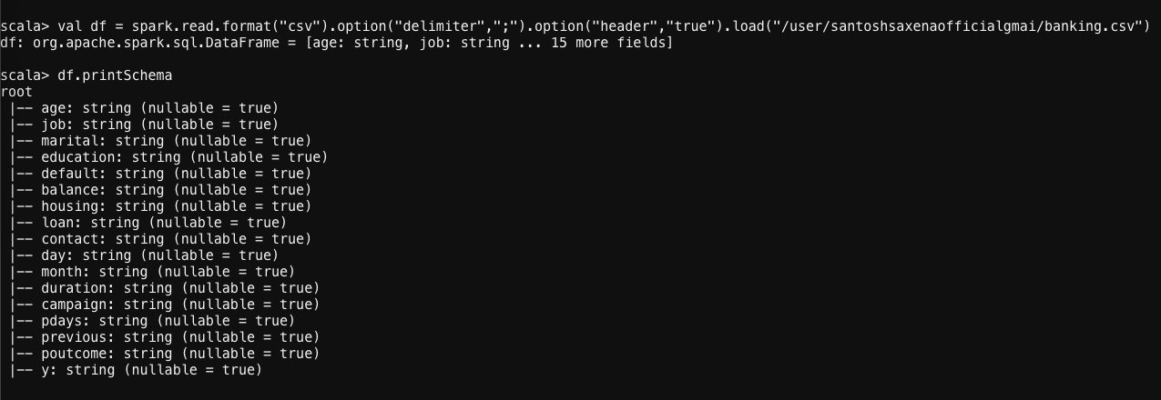

Q2 . Give marketing success rate (No. of people subscribed / total no. of entries) ?



Q3 . Give marketing failure rate ?

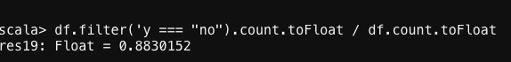

2nd part

Q1 . Give the maximum, mean, and minimum age of the average targeted customer ?

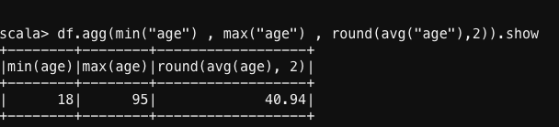

Q2 . Check the quality of customers by checking average balance, median balance of customers ?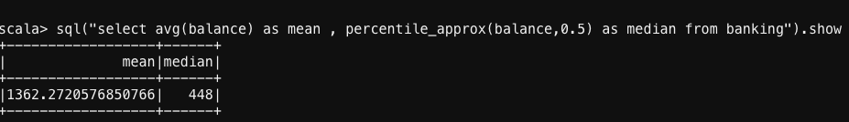

Q3 . Check if age matters in marketing subscription for deposit

Ans 3 .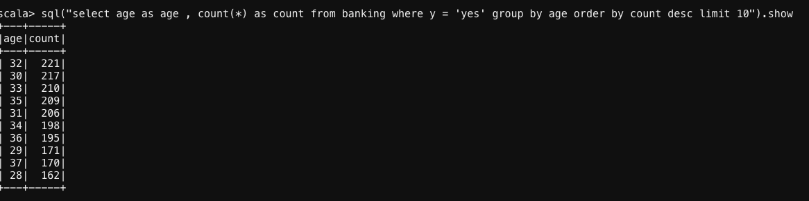

Q4. Check if marital status mattered for a subscription to deposit

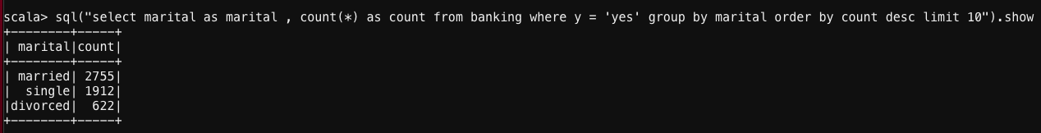

Q5. Check if age and marital status together mattered for a subscription to deposit scheme

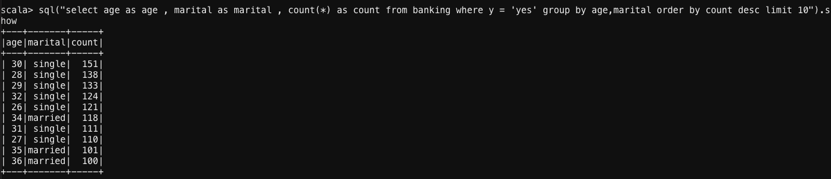

Q6. Do feature engineering for the bank and find the right age effect on the campaign. ?



